**BACHELOR THESIS**

**RNA binding motifs reveal tendencies towards autologous binding**

submitted by

**Moritz Haderer**

in partial fulfillment of the requirements for the degree of

**Bachelor of Science (BSc)**

Vienna, 2022

**UA 033 630**

**Bachelor’s degree programme Biology**

**Univ.-Prof. Dr. Bojan Zagrovic, BA**

Degree programme code as it appears on the

student record sheet:

Degree programme as it appears on the

student record sheet:

Supervisor:

**Abstract**

The central dogma of molecular biology [1] is a proposed model for the passing down of genetic information in the cell. While it captures the essence of life on a molecular level, there are types of interactions that are difficult to understand when viewed from this perspective. Interactions between RNA-binding proteins (RBPs) and RNA count among them. They are integral parts of many cellular processes such as post-transcriptional regulation, RNA transport- and localization as well as post-transcriptional modification of RNA. As RBPs play a guiding role in these interactions, their availability needs to be tightly regulated so as to ensure proper cellular functioning. Autoregulatory feedback between RBPs and their own mRNAs [2] often lies at the heart of these regulations. The recently brought forward complementarity hypothesis helps understand how such interactions between proteins and their own mRNA can occur. As it is a relatively recent hypothesis, it suffers from a lack of experimental results. Given some new data in form of protein-RNA interaction profiles, a possible systematic analysis of the theoretical binding behavior of RNA binding proteins is presented here. The results of the analysis show a general trend towards autologous interactions of RBPs with their own mRNAs. These interactions happen more readily when an RBP’s binding preferences are relatively unspecific. While protein-RNA interactions can happen highly specifically, these vaguer interaction profiles point towards the alignment of certain more low-level physicochemical properties of these biomolecules. As the central dogma states, information flows from RNA to protein. Perhaps, this flow of information includes properties that allow a protein to recognize its original mRNA in a global manner and, therefore, bind and regulate it.

Contents

1. Introduction 5

1.1. RNA-binding domains 5

1.2. Data acquisition methods 6

1.3. General workflow 8

1.4. Results 8

2. Materials and Methods 9

2.1. Datasets 9

2.1.1. RNAcompete [11] 9

2.1.2. SELEX [11] 9

2.1.1. HT-SELEX (2020) [16] 10

2.1.2. MANE select (v0.95) transcriptome 10

2.2. Methodology 11

2.2.1. Motif occurrence null model 11

2.2.2. Sequence motif search 11

2.2.3. Sequence motif search – FIMO [10] 11

2.2.4. Evaluation of motif-occurrence enrichment 12

2.3. Extended introduction 14

2.3.1. Position frequency matrix 14

2.3.2. Position probability matrix 15

2.3.3. Position-specific scoring matrix 15

2.3.4. Scoring an occurrence 17

2.3.5. Threshold setting 18

2.4. FIMO [10] 18

2.4.1. FIMO Input 19

2.4.2. FIMO output 19

3. Results 21

3.1. Enriched occurrence of motif sequences in RBP’s autologous transcripts 21

3.1.1. Normalization by number of matrices per protein 21

3.1.1. Data restriction to single matrix per protein 23

3.2. Reproducibility using exact motif-sequence matches 25

4. Discussion 27

5. Supplementary Figures 29

5.1. Dataset properties 29

5.2. Normalized analysis using multiple matrices per protein 31

5.3. Analysis using single matrix per protein 32

6. References 33

7. Acknowledgements 36

8. Appendix 37

# Introduction

RNA binding proteins (RBPs) are a class of proteins that interact directly with RNA molecules [3]. These interactions have been found to involve very important cellular processes such as post-transcriptional modification and regulation of translation [4], RNA transport and localization as well as mRNA splicing [5]. Although being central to many cellular processes, the interactions between these important proteins and RNAs have not been studied to the extent they merit.

The recently proposed “complementarity hypothesis” creates a framework for understanding these protein-RNA interactions in a general sense. According to this framework, whenever genetic information flows from mRNA to protein, the physicochemical properties of the mRNA sequence are translated to the physicochemical properties of the protein. Hence, the stretch of mRNA that codes for a given RNA-binding domain transfers a certain affinity towards itself. The complementarity hypothesis therefore states that RNA-binding domains have general affinity towards the mRNA they originated from. This flow of information is what constitutes the genetic code, being a dictionary for mRNA-to-protein translation. In fact, it has been found that translation does not simply go from base to amino acid, but rather involves passing down physicochemical properties. This phenomenon yields fascinating insight into affinity of proteins to their cognate mRNAs [6].

## RNA-binding domains

During evolution, RBPs got more and more specialized to recognize specific RNAs [5], developing binding regions that show affinity only to a specific type of recognition pattern of ribonucleic acids. These patterns are often called “motifs” and are one of the central topics of this thesis.

Recognition motifs could be structurally traced back to certain binding domains that exist within the 3D-structures of proteins. These domains have developed affinity for relatively specific sequences of ribonucleotides. While some domains prefer specific sequences of nucleotides, others bind to the phosphate backbone of RNA, being less nucleotide specific. Some domains bind linear RNA molecules, others bind complex structures or even unstructured RNAs. To have a more concrete idea of protein-RNA interactions, some knowledge of the most common RNA-binding domains is useful. Among those common domains are the RNA-Recognition Motif (RRM), the Double-stranded RNA-binding Motif (dsRBM), K-Homology domains, and RG/G repeats.

**The RNA-Recognition Motif** is found in 0.5%-1% of human genes and consists of a stretch of 90 amino acids. With conserved regions containing a handful of aromatic amino acids that bind the RNA in a base-unspecific manner, the composition of the surrounding β-sheets allows for nucleotide-specific binding.

**The Double-stranded RNA-binding motif** prefers to bind double-stranded RNAs. This also implies that these interactions are less specific, as the base-information is not as readily available as on a single-stranded nucleotide and the domain must resort to binding the phosphate-backbone. What these interactions lack in nucleotide-specificity, however, they make up in recognition of complex-structured RNA-molecules.

**K-Homology domains** are commonly able to bind a wide variety of four-nucleotide long sequences. As this alone would not suffice in efficient motif recognition, this domain has found ways of increasing its specificity. In some situations, a neighboring α-helix is integrated into its RNA recognition domain, thereby allowing efficient binding of six nucleotides. In other cases, KH-domains appear in repeats, which further increases specificity.

**RG/G (Arginine-Glycine/Glycine) repeats** are RNA-recognition domains that can interact with RNA molecules via their Arginine residue. They are usually found in intrinsically disordered protein regions and are hypothesized to play a role in protein phase-separation. As a single RGG region does not show enough specificity for efficient RNA binding, they are most often found in repeats, thereby increasing specificity.

## Data acquisition methods

As experimental results for the complementarity hypothesis are scarce, we resort to in-silico analysis of protein-RNA interaction data for insight. The emergence of high-precision technologies like RNAcompete and SELEX, being methods that enable the determination of the exact nucleotide motifs a given RBP can recognize, facilitates this type of analysis a great deal.

Figure 1: Description of experimental techniques for RBP binding preference determination [7]

**RNAcompete** [8] is an in-vitro experimental technique where a Glutathione-S-Transferase-tag is added to an RBP of interest. The modified RBP is then incubated in a large pool of RNAs (~ 250 000 molecules) that has been designed to cover all combinatorically possible sequences of up to 9 bases. After incubation of the RBP in an environment holding an excess of RNA, a pull-down assay is performed, eluting all RNA sequences that have been bound by the tagged RBP. The bound sequences are then separated from the RBP and hybridized against a microarray. As this assay is carried out in a large excess of RNA, the relative abundance of bound sequences indicates relative binding affinity.

**SELEX** [9], or “systematic evolution of ligands by exponential enrichment”, is another in-vitro technique for finding consensus motifs for RBPs. A SELEX run begins with a pool of DNA sequences of equal length, covering all combinatorically possible sequences. The DNA is in-vitro transcribed and an RBP is incubated in the resulting pool of RNA. Once incubation is finished, the unbound RNA sequences are washed out, whereas the bound targets are separated from the RBPs and reverse-transcribed to cDNA, which is then amplified via PCR and serves as the new starting point for the next SELEX run. After a certain number of runs, the resulting “winner” sequences are sequenced.

**High-throughput SELEX** [7] differs from SELEX in that a sample of all bound RNAs is sequenced using high-throughput methods after every run, thus allowing for the estimation of possible alternative binders.

## General workflow

Using datasets consisting of RBP-RNA binding motifs, an analysis of the theoretical binding affinities of RBPs towards their own mRNAs is attempted in the context of the complementarity hypothesis. The presence of experimentally validated RNA-binding motifs within sequences of the human transcriptome is interpreted as a measure of affinity of a given protein towards a transcript. As the set of tested transcripts includes all autologous mRNAs of the proteins under investigation, a statistical test can reveal an enrichment in affinity. If RBP motifs are indeed enriched in their own mRNAs, this may further support the findings that RBPs play a role in the regulation of their own transcripts. To determine the binding affinity between an RBP and a given mRNA, the occurrence of RNA-binding motifs within the RNA sequences is investigated using the tool FIMO by MEME Suite [10].

## Results

Three different approaches were taken to show the affinity of RBPs to mRNAs. First, FIMO was used to calculate a coverage value for each protein in the dataset, using multiple matrices per protein were when available and normalizing the resulting coverages by the number of matrices. Second, the same approach was taken only using a single matrix per protein in order to eliminate possible biases created by non-homogeneous utilization of matrices. Third, an exact-matching procedure was applied to the same dataset. The investigation revealed significant enrichment in autologous binding within the 3’-UTR and the full transcript of cognate mRNAs of RBPs in the first two approaches, while enrichment of nearly all subsequences could be observed in the exact matching analysis.

The robustness of these results, considering the probabilistic and generalized methods utilized to test the effect, supports the hypothesis that proteins may show affinity towards their cognate mRNAs. However, a further in-depth investigation is necessary to reveal exactly how and when these important interactions most likely occur and how they affect all cellular processes.

# Materials and Methods

## Datasets

### RNAcompete [11]

The ATtRACT database by Giudice et al. (downloaded at [ATtRACT-database](https://attract.cnic.es/download)) contains RNAcompete results for 194 RBPs in 24 different organisms. For each RBP, at least one consensus sequence is provided as well as information on the protein domain involved in binding and a quality score, being a numerical representation of binding affinity. RBPs are labelled by their gene-IDs according to Ensembl [12], Xenbase [13]or the European Nucleotide Archive [14]and gene names as provided in UniProt [15].

The data was filtered to include only human RBP motifs. As proteins can bind different motifs with varying consistency, the database includes a quality score for each motif, serving as a measure of reliability. Only the motifs with the highest quality scores among were included. The resulting entries each contained a matrix ID referencing a position-probability matrix, yielding a total of 96 matrices for 77 proteins.

### SELEX [11]

The ATtRACT database also contains SELEX results for 41 RBPs in nine different organisms. As for RNAcompete, SELEX data was filtered to only include human entries exhibiting the highest quality scores. After filtering, 26 RBPs remained, many of which bound to multiple significantly different motifs. A total of 46 PPMs could be used in the analysis.

### HT-SELEX (2020) [16]

Jolma et al. carried out a large High-throughput RNA-SELEX study with the goal of discovering and validating RNA binding motifs of human RNA binding proteins. The resulting data can be downloaded from the [European Nucleotide Archive](https://www.ebi.ac.uk/ena/browser/view/PRJEB25907?show=reads). It includes known RBPs, isolated RBP-binding domains as well as proteins that have been observed to bind RNA but are not among the canonical class of RBPs. All in all, this study yielded 145 binding models for 86 proteins. The database contains information on the structural preferences of specific proteins, indicating whether they bound to linear RNA rather than folded RNA. Furthermore, some RBPs have been found to bind RNA as dimers.

As the goal of this analysis is to explore motif coverage over linear RNA sequences of single RBPs, all dimeric binders and RBPs with structural preferences were excluded from the dataset. Additionally, one protein was not available in the MANE select database (as described below) For each protein, at least one position probability matrix was provided, in the end resulting in 49 proteins yielding 69 matrices.

### MANE select (v0.95) transcriptome

MANE, or “Matched Annotation from NCBI and EMBL-EBI“, is a large-scale collaboration between the National Center for Biotechnology Information and the European Bioinformatics institute as a Branch of the European Molecular Biology Laboratory. The database is available for download on [the NCBI homepage](https://www.ncbi.nlm.nih.gov/refseq/MANE/).

Its goal was to create a clearly annotated and matching database for human transcriptome data. It now covers over 18.000 transcripts with detailed information on each protein-coding gene’s location, function, 3’-UTR, 5’-UTR and coding sequence (CDS) length. The MANE database represents the transcriptome with equal weight per gene, rather than weighting by the number of transcript variants. Due to this weighting, only the best supported transcript for each gene is included.

## Methodology

### Motif occurrence null model

To assess enrichment in autologous binding, a distribution of binding affinities serving as a null hypothesis is necessary. The MANE select database, being a large repository for almost 98 % of the human transcriptome, adeptly fit this purpose. As this analysis explores the binding affinity of RNA binding proteins to their autologous mRNAs, the average affinities of RBPs to mRNAs must be established. With a null-model of RBP-mRNA-compatibility in place, p-values for autologous interactions can be derived.

### Sequence motif search

In a sequence motif search procedure, an alignment of RNA-binding motifs to every subsequence along a transcript is attempted and exact matches reported. From a probabilistic perspective, motif length plays a big role in an exact matching procedure. Since only the exact alignment of a motif to the scanned RNA stretch will count as a match, shorter motifs would be represented considerably more often in any random sequence than longer motifs would. To remedy this bias, motifs were fragmented to a specified size. Whenever a motif exceeded the desired length, every possible subsequence of this motif was used to determine a combined coverage value. The matches of individual motif fragments would finally be combined, showing matches per complete motif.

### Sequence motif search – FIMO [10]

Probability matrices offer a probabilistic approach to the sequence motif match finding problem. Matrices are created from experimentally determined motifs. As RBPs can bind motifs with a certain degree of variability, the probability of a certain nucleotide appearing at any position can be calculated and combined to form a position probability matrix. When a matrix is placed against the sequence to test, a score is calculated by adding up/multiplying the values in the matrix that correspond to the sequence of letters. How exactly this scoring procedure happens is explained in detail in the extended introduction.

FIMO performs sequence motif search over a set of sequences using the position probability matrices provided. Every matrix is run over every sequence, yielding a score for every position the matrix is compared against as well as a p-value corresponding to the score. A match is reported whenever the calculated p-value is lower than the p-value cutoff specified by the user. For short motifs, a stringent p-value cutoff can lead to incomplete results. This is due to fact that matrices with a length of six nucleotides or less can only achieve 46 (or 4096) different scores. Since the p-value is calculated via the probability that a certain score occurs in the distribution of all possible scores, this probability being $\frac{1}{4096}$, the p-value cutoff of $\frac{1}{10 000}$ can never be satisfied. As matrices get longer than seven nucleotides (47 = 16 384), surpassing this threshold becomes possible.

The motif data coming from RNAcompete, SELEX and HT-SELEX experiments as well as the MANE select database were written to text files according to the format specifications FIMO uses and motif search was performed for a variety of p-value cutoffs. As FIMO uses PSSMs rather than PPMs (a detailed explanation of matrix types can be found in the Extended introduction), a nucleotide background distribution of the scanned transcripts should be provided. This background distribution was chosen to be a zero-order Markov model based on the entire MANE select transcriptome data. Finally, FIMO returns a list of matches, each entry of which contains all necessary identifiers, the p-value of the score and the start and stop indices of the match in the transcript.

### Evaluation of motif-occurrence enrichment

Sequence motif search was carried out for every transcript found in the MANE transcriptome database. Any significant motif-sequence alignments were reported as matches, which were then combined to a coverage value. Coverage indicates how often a given motif is present on a transcript sequence and is calculated as portrayed by the following example:

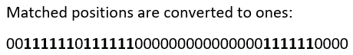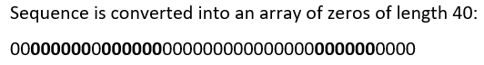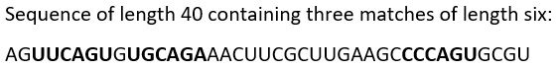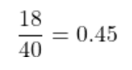

The given sequence has a coverage value of 0.45 or, in other words, 45 % of the sequence contain matches to the matrix. In a real-life example, the sequence would be significantly longer, and the coverage value would be expected to be several magnitudes lower.

Enrichment in motif-occurrence is evaluated by comparing the coverage value of each transcript to the mean coverage a motif achieves. To this end, a z-score for every transcript is calculated.

Equation 1: The z-score is determined using this equation. covtranscript is the coverage value of a given transcript, covµ is the mean coverage over all transcripts and covσ is the standard deviation over all coverage values.

## Extended introduction

### Position frequency matrix

Experiments for finding new motifs of RNA binding proteins will yield a number of motifs that have been bound by the RBP. These motifs will often be similar in length and composition. To account for non-similarities between bound motifs, the Position Frequency Matrix helps visualize the number of times a given nucleotide was found at position P of the motif. As the name suggests, it indicates the frequency of nucleotides at a position.

A list of ten motifs bound by a given RBP in an experiment might look like this:

Figure 2: Example for experimental sequences used to construct PFM

Counting the number of times nucleotides are observed in a given position, a PMF of the following structure can be constructed:

Figure 3: Position frequency matrix (PFM)

### Position probability matrix

In a similar fashion to the position frequency matrix, the position probability matrix (or PPM) gives clear insight into the proportions of nucleotides bound at a given position. The main difference between the PFM and the PPM is a count-normalization to probability values (ranging from 0 to 1). This is done by dividing the frequency by the number of bound motifs. Continuing with the example from above, the corresponding PPM would be created by dividing each frequency count by ten:

Figure 4: Position probability matrix (PPM)

In practice, the position probability matrix can be used to give a probability score to a novel motif by multiplying the letters’ corresponding probabilities over all positions. In a programmatical context, one usually deals with rather long/a large number of motifs to assign a score to. Potential downsides of this type of matrix are 1) multiplication is a more expensive computation than, e. g., addition. Once the sequences to be scored exceed a certain length, this is noticeable in the duration of computations. Another downside is that multiplication of very long matrices can lead to underflowwhen computing the score of a motif. When multiplying many small numbers, floating point precision can be thought of as a resource. This effect might skew the scoring and, consequently, determination of sufficiency of a score.

### Position-specific scoring matrix

To remedy both downsides of the PPM, a third type of matrix can be employed. The position-specific scoring matrix (PSSM), also called position weight matrix, can be derived from the PPM. It incorporates the background distribution of nucleotides of the target sequences. By computing the log-likelihood ratio of a nucleotide’s probability given the background distribution, the matrix’ entries can now be both positive and negative. The reason behind the alternative name “position weight matrix” is given by the interpretation of what these resulting values express: a positive value puts strong weight on a given nucleotide, while a negative value indicates that this nucleotide should occur less often at that given position than the background distribution would suggest, thus reducing its weight.

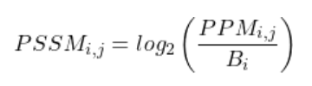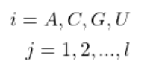

Figure 5: Constructing a Position-specific scoring matrix by taking the binary logarithm of the likelihood-ratio. In this example, a uniform background distribution of 0.25 per nucleotide is assumed. The log-likelihood ratio L is given by the binary logarithm of the probability of nucleotide i at position j, divided by the probability of a nucleotide as given by the background   
distribution B.

Applying these manipulations to the PPM in the previous section, we get the following matrix:

Figure 6: Position-specific scoring matrix (PSSM)

#### Pseudocounts

Since the logarithm is not defined at zero, the resulting matrix contains placeholders for an undefined value – often in form of negative infinity. A simple method to alleviate this issue is adding “pseudocounts” to the probability values in the PPM. In most practical applications, a pseudocount value of 0.1 is added to each entry in the position probability matrix. Doing this for the above PPM leads to the following PSSM:

Figure 7: Position-specific scoring matrix (PSSM) with pseudocounts

### Scoring an occurrence

Every matrix encodes the affinity of an RBP for a certain motif. While exact motifs can be derived from the matrix, the probabilistic view of affinity is what makes this approach so popular. Instead of looking for an exact overlap between a “best” motif in a sequence, a matrix is “slid” over the sequence and a score is calculated at every position by adding up the value of the respective nucleotide in the matrix. Using the PSSM from above, the following scores can be assigned to the bold-marked sequence positions below:

Figure 8: Scoring procedure for a sequence given a PSSM

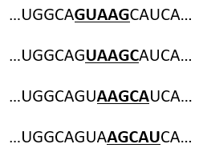

0.26 + (-1.32) + (-1.32) + 2.14 + (-1.32) = **-1.56**

(-1.32) + 0.26 + (-1.32) + (-1,32) + 0.26 = **-3.44**

2.14 + 0.26 + (-1.32) + (-1.32) + 1.85 = **1.61**

2.14 + 1.68 + (-1.32) + 2.14 + (-1.32) = **3.32**

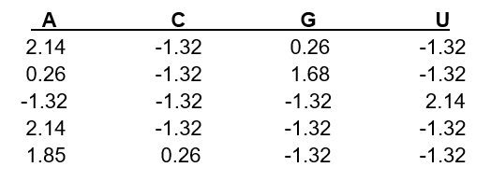

Having calculated the corresponding scores, it is hard to say whether each score represents a “strong” or a “weak” match of a protein to a motif. To set the threshold where a score is deemed sufficient, certain statistical methods are necessary.

### Threshold setting

A motif of length five contains 45 computable scores. This arises from the fact that each nucleotide can come at any position. By computing all possible scores a matrix can yield, a score distribution is created. The PSSM from the example above leads to the distribution in Figure 9. When a percentile significance threshold is chosen, for sake of example let this be 0.05, then all scores that lie within the top 5 % of the distribution will be considered sufficient.

Figure 9: Score distribution of PSSM.

While this approach is statistically sound, creating the entire distribution of scores poses a computational problem as the length of the matrix increases. With a matrix of length 15, 415, so more than a billion, scores would have to be computed. To deal with this computational constraint, an approximation of the matrix-specific threshold can be computed by randomly sampling the possible nucleotide arrangements. As Pan and Phan [17] state in their paper, determining score thresholds by using random sampling rather than computing a full distribution was “verified to be technically identical” to creating the full distribution, if sampling size was larger than 410

## FIMO [10]

FIMO is a tool offering discovery of motif occurrences in sequences as a part of the MEME Suite package [18]. It is used for the scanning of sequences with a set of motif matrices and returns all significant matches that may occur. A significance threshold can be set by the user.

### FIMO Input

#### Motifs

FIMO takes as an input tab-separated-value files containing position probability matrices with headers containing an identifier, additional information, the matrix length and width and more optional data. At the top of the file, some information on the MEME Suite version used as well as the alphabet the motifs are coding for.

These files are appropriately output by some of the MEME Suites software tools but can also be created from scratch by following the simple formatting layout provided by FIMO. Alternatively, FIMO offers a variety of conversion tools for common file types encountered in the space of motif analysis.

#### Sequences

The sequences must be handed to FIMO in “.fasta” or, alternatively, “.fna”-format. Files of this format contain a unique identifier, such as a gene ID, and the sequence in question.

#### Background nucleotide frequency distribution

When PSSMs are used for discovery of motif occurrences, the distribution of nucleotide frequencies in the searched sequence plays a vital role. As discussed in the previous section, these nucleotide frequencies are involved in computing the PSSM entries from a PPM, yielding a positive value when the probability of a given nucleotide in the PPM is lower than the background probability of the same nucleotide and a negative value when the opposite is the case. An interpretation of this effect is that positive values in a PSSM indicate that the motif diverges from the set of motifs the background distribution would suggest are most likely.

### FIMO output

Using the commands as they are elaborated upon in the appendix, one file per analysis is output by FIMO. Each file contains a header and all information on a single significant match in one line. This includes information on identification:

* **the matrix used for scoring**
* **the experiment the matrix originates from**
* **the transcript the match occurred in**

as well as information on the details the match:

* **the position in the full sequence the match started at (start) and ended at (stop)**
* **the strand direction the motif was found in**
* **the exact score achieved by the scored subsequence**
* **the p-value of the score**
* **an empty column for q-values (not computed in this example) and**
* **the exact subsequence matched by the motif**

Figure 10: The output of a FIMO analysis. The contents of this table are described in detail above the figure.

# Results

## Enriched occurrence of motif sequences in RBP’s autologous transcripts

The hypothesis that proteins have affinity towards their own coding sequences, the complementarity hypothesis, not only predicts, but reveals the importance of autologous feedback in post-transcriptional regulation of RBP-coding genes.

To test this hypothesis, the enrichment of RBP affinity motifs in autologous mRNA sequences was analyzed. The ATtRACT database [11] as well as the HT-SELEX experiment of Jolma et al. [16] are some of the most comprehensive sources for RBP motif data available, while the MANE select database serves as a null-model for motif enrichment in the entire transcriptome. FIMO [10] was used to scan the transcriptome sequences for motif matches. Once motif-sequence matches were found, the density of motif occurrences in each transcript sequence was calculated and autologous enrichment was determined using a z-test. Depending on the p-value cutoff specified beforehand, stringency could be regulated. A lower cutoff (e. g. of 1e-4) includes sequence-motif matches that can be interpreted as highly specific, whereas a less stringent one allows for more fuzzy interactions to be considered significant. As different levels of stringency were of interest, each analysis was carried out at a p-value cutoff of 1e-4, 1e-3, 1e-2 and 0.05.

### Normalization by number of matrices per protein

As a first approach, multiple matrices per protein were used when available in the dataset. In order to eliminate the biases created by some proteins containing multiple binding motifs, a normalization was applied. The calculated coverages for each matrix were combined and divided by the number of matrices.

Using this method at a p-value cutoff of 0.05, significant enrichment in autologous binding could be observed in two of three experiments. RNAcompete and HT-SELEX motifs were found considerably more often in autologous mRNAs as opposed to the entire transcriptome. In particular, the 3’-UTR and the coding sequence (CDS) show complementarity to their cognate proteins’ binding motifs. While SELEX shows no significant enrichment (p-value below 0.05), the RBP motifs exhibited stronger affinity towards their autologous CDS than to the entire transcript. This interesting effect might be explained, firstly, by the nature of PSSMs and , secondly, by the way FIMO measures significance. A PSSM’s entries are computed taking into account the distribution of nucleotide frequencies in the background. As the full transcriptome’s nucleotide frequencies were used for both analyses, the CDSs of the proteins available in SELEX seem to have a higher density in high-significance matches for autologous interactions.

Figure 11: At a p-value cutoff of 0.05, significant enrichment in autologous binding could be observed. For each protein, at least one matrix was used to scan for matches.

The vertical axis of this plot shows the distribution of z-scores, while the horizontal axis is separated into the three datasets that were used in the analysis (RNAcompete, SELEX, HT-SELEX). The left side of each part of the triplet visualizes the z-scores of autologous matches in their respective sequence   
(1. UTR3, 2. CDS, 3. UTR5, 4. full transcript) as well as the mean of these z-scores in the respective color. The right side describes the distribution of z-scores over the entire background, with the mean fixed at zero. Below each plot, the number of matrices that found matches in the transcriptome is shown contrasted to the total of matrices available in the dataset. The p-values below these numbers stem from a one-tailed z-test describing the probability that the autologous matches’ z-scores came from the same distribution as the null-model z-scores.

The analysis using a p-value cutoff of 0.01 showed largely similar results. In RNAcompete and HT-SELEX, both the full transcripts’ and the 3’-UTRs’ coverages gained in significance.

These results, however, were not reproduced with more stringent cutoffs, as can be seen in Figures 12 and 13. This is understandable, as short motifs may not have 1e3 or 1e4 different possible scores and, therefore, cannot produce matches. This fact is illustrated by a reduction in the number of proteins exhibiting matches as the cutoff increases.

What could, however, be observed was a stronger tendency towards outliers as stringency was increased. Since individual proteins are represented by colored dots spreading along the vertical axes of each experiment, this effect is visualized clearly.

Figure 12: At a p-value cutoff of 0.01, significant enrichment in autologous binding could be observed. For each protein, at least one matrix was used to scan for matches.

### Data restriction to single matrix per protein

As a second approach, only one matrix per protein in the datasets was used. This means that, even though some proteins are able to bind more than one type of motif, thus resulting in multiple probability matrices per protein, only one matrix per protein was used in scanning the transcriptome using FIMO. This restriction in data was of interest as it leads to results that remain unbiased in terms of coverage values per protein. As differences in quality scores among the set of matrices available for a single RBP vary only slightly, the one appearing in the last position of each set was chosen for this analysis.

For p-value cutoffs 0.05 and 0.01, which only include motif-sequence match-scores within the top 5 % or 1 %, respectively, a significant effect could indeed be observed. The coverage values of RNAcompete and HT-SELEX motifs in 3’-UTRs as well as in the full transcripts lie in the 99th percentile of the average coverage that could be observed in the entire transcriptome. In Figure 14 and 15, this effect is portrayed by a positive deviation from the horizontal mean-line in any of the subsequence coverages.

Figure 13: Analysis of enrichment in autologous binding using FIMO with a p-value cutoff of 0.05. This analysis includes only one matrix per protein

Figure 14: Analysis of enrichment in autologous binding using FIMO with a p-value cutoff of 0.01. This analysis includes only one matrix per protein

## Reproducibility using exact motif-sequence matches

In an exact matching procedure, an alignment of these “best” motifs to every point along a sequence is attempted and exact matches reported. From a probabilistic perspective, motif length plays a big role in an exact matching procedure. Since only an exact match between the protein’s motif and the scanned RNA stretch will contribute to coverage, shorter motifs would be represented considerably more often in any random sequence than longer motifs would. To remedy this bias, motifs were fragmented to a specified size. Whenever a motif was longer than allowed, every possible subsequence of this motif was used to determine a combined coverage value. Figure 17 shows a distribution of motif lengths among all experiments.

An analysis of this type was carried out on the same dataset as the previous ones. One difference to remark is in the number of motifs available. While RNAcompete and HT-SELEX offer matrices for each binding motif, this is not the case in SELEX. This dataset includes more motifs than in the previous analysis, as a set of similar motifs, for which only one matrix would be available, was listed as multiple individual entries.

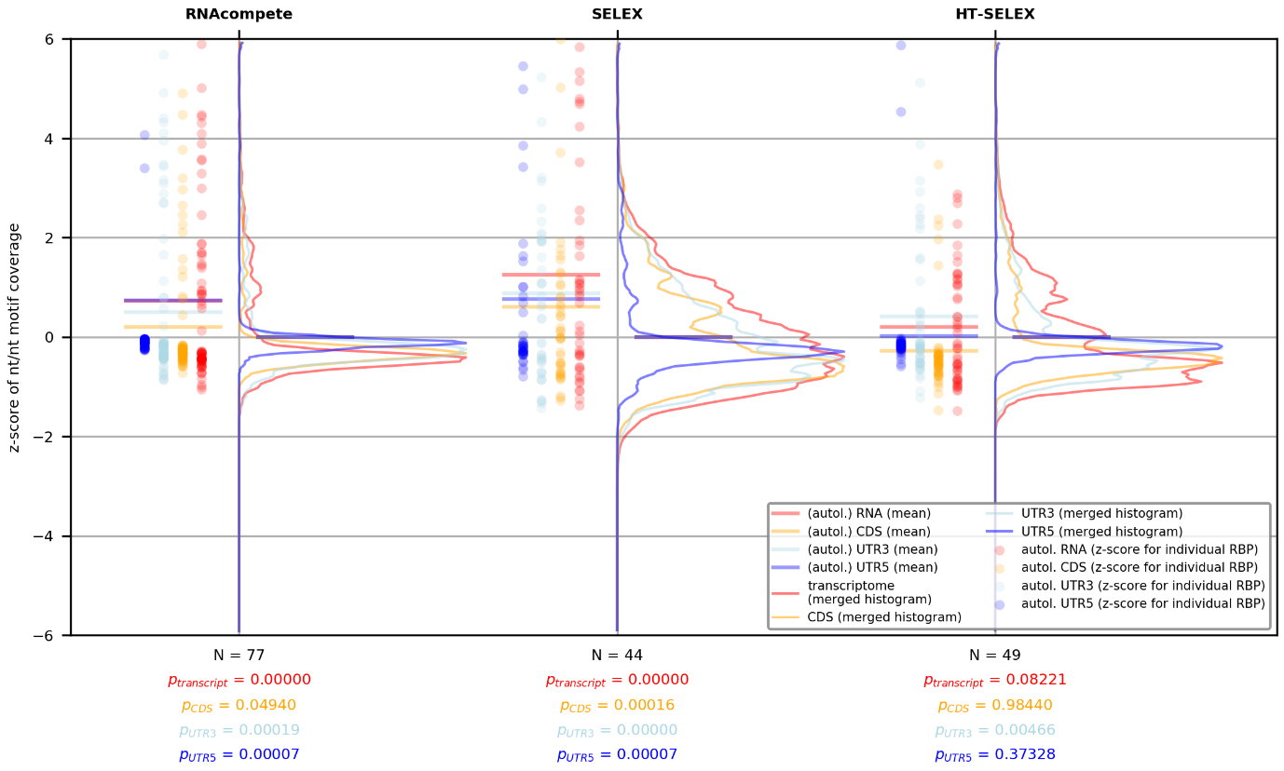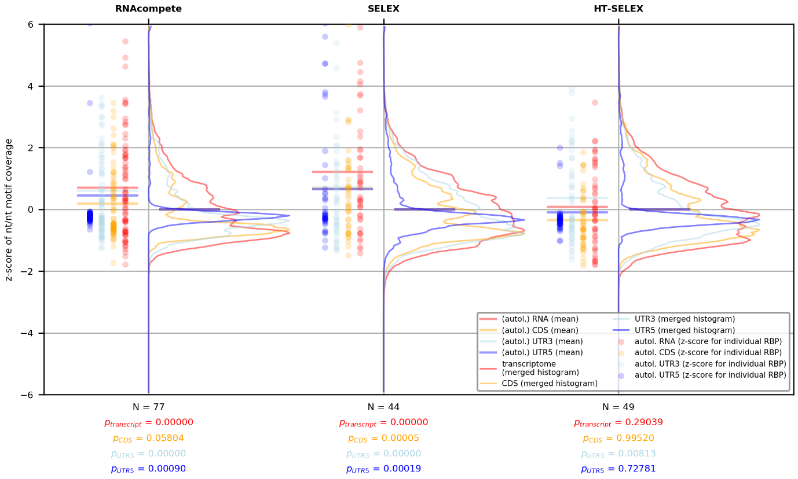

Figure 15: Exact matching procedure using motif length cutoff of 6nt (top) and 7nt (bottom) with shuffled transcriptome sequences as a null-model. In both analyses, enrichment of autologous binding could be observed. The CDS shows the highest average density in exact motif-sequence matches.

# Discussion

The complementarity hypothesis has led to some insightful findings involving protein-RNA interactions [6] [19] and presents a powerful framework for why these interactions can occur. Using position probability matrices as a mathematical model for the binding affinities of a protein’s binding domain, this framework was put to the test in a search for motif occurrences in the human transcriptome using FIMO.

The findings of the analysis carried out here show that RNA-binding proteins have, on average, higher affinity for their cognate mRNAs when the landscape of considered interactions extends beyond the highly specific kind. This effect is apparent in the variation of a p-value cutoff determining what counts as a valid interaction: at 0.05 and 0.01, where the top 5 % and top 1 % most specific motif-sequence matches are considered, respectively, enrichment in autologous binding was observed. A possible interpretation of this fact may be that very small nudges, rather than highly specific forces, are what drive the chaotic landscape of electrostatic interactions between proteins and RNAs. These small nudges, like non-specific affinity profiles between RBPs and autologous mRNAs, can, on average, cause significant differences in binding behavior.

It is, however, certainly not enough to point to complementarity of physicochemical properties of biological macro-structures for explaining the wide range of protein-RNA interactions out there. The presence of identifiable RNA-binding domains within proteins, some of which bind highly specifically, indicates that it is also point-wise congruence that drives an RBP to bind a given mRNA. As certain RNA-binding domains are pickier in their choice of partner than others, may we turn to the complementarity hypothesis as an underlying force which helps proteins pre-select their binding partners in the densely populated molecular landscape of the cell?

In the context of RNA-binding proteins, autologous binding has been found to be important in post-transcriptional regulation of mRNA: an RBP’s affinity towards certain regions of its cognate transcript might be suggestive of an autoregulative feedback loop, keeping translation low when the levels of a RBP are high.

As the enrichment is especially strong when looking at the 3’-UTR and the entire transcript, a certain correlation with the average length of the scanned sequences can be observed. A background frequency distribution (Figure 16) of the entire transcript is used in constructing the PSSMs. This, however, contains no information about where in the transcript certain nucleotide combinations are more likely to occur. Since the 3’-UTR is known to be involved post-transcriptional regulation of mRNA, a higher density in motifs in this context together with the high average length of the 3’-UTR would directly influence the enrichment of binding in the full transcript. Figure 16 also shows that the 3’-UTR is higher in G and C than the full transcript. In [6], Žagrović and Polyansky mention that Guanine and Cytosine play a special role in complementarity interactions, thus raising the question, whether enrichment in this untranslated region may point to an evolutionarily conserved density of G and C in these contexts.

# Supplementary Figures

## Dataset properties

Figure 16: Nucleotide frequency distribution in the sequences scanned by FIMO.

Figure 17: The y-axes of each subplot are normalized to the total number of matrices of a given length; the x-axes are normalized to the maximum motif length available in the dataset.

Figure 18: The y-axis shows the number of proteins in the dataset for which a given number of matrices are available.

## Normalized analysis using multiple matrices per protein

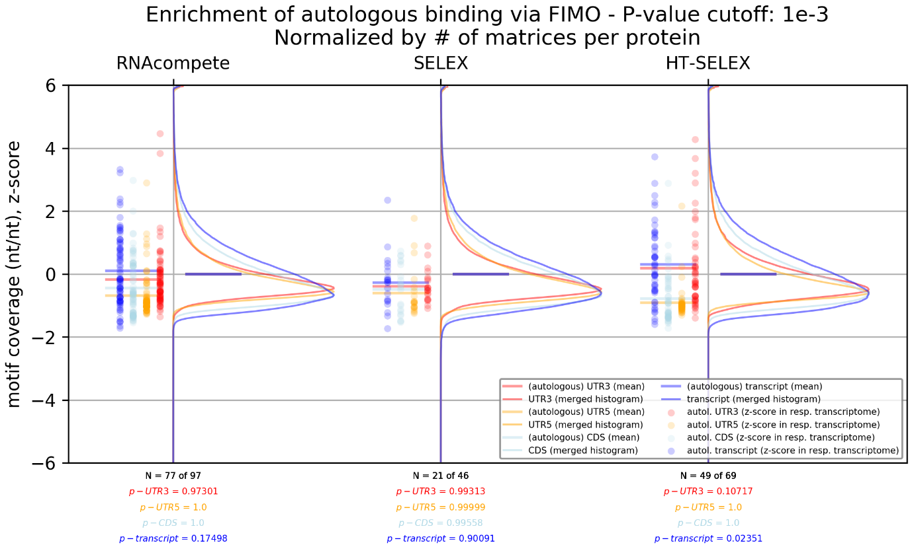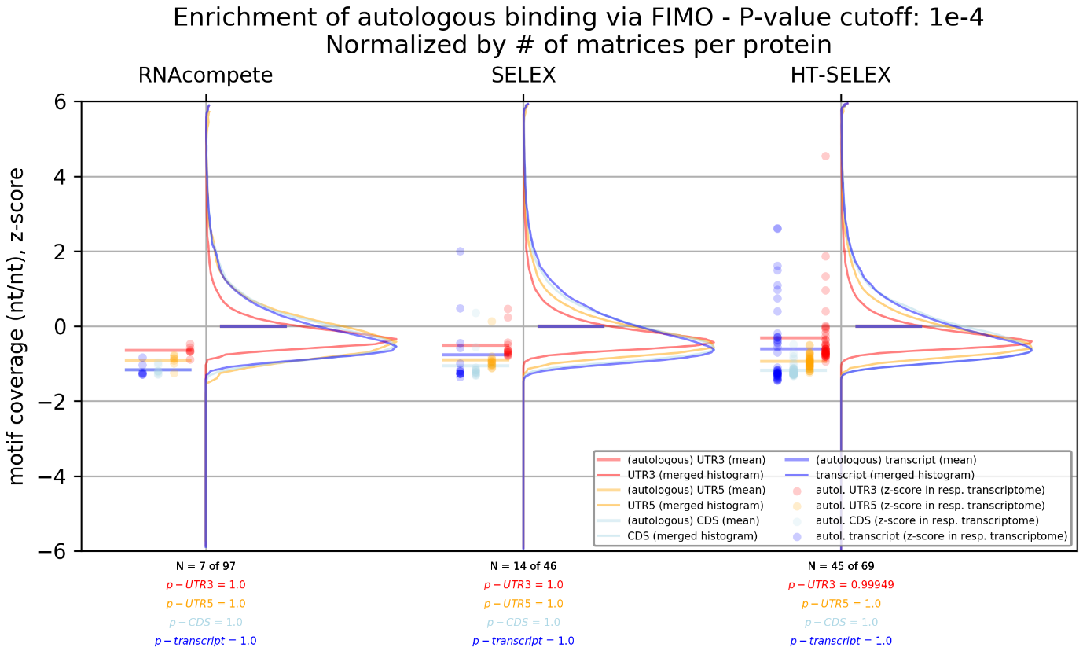

Figure 20: At a p-value cutoff of 0.001 (top) and 0.0001 (bottom), significant enrichment in autologous binding could no longer be observed. For each protein, at least one matrix was used to scan for matches.

## Analysis using single matrix per protein

Figure 21: At a p-value cutoff of 0.001 (top) and 0.0001 (bottom), no significant effect could be observed for an analysis of autologous transcript motif coverage using a single matrix per protein

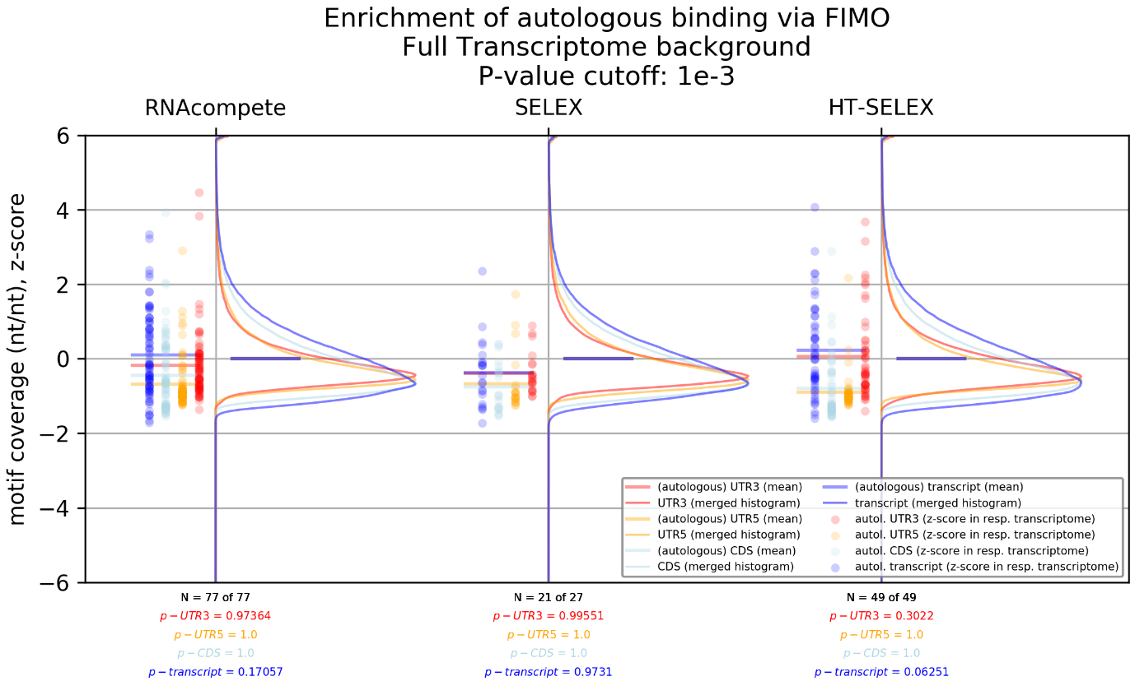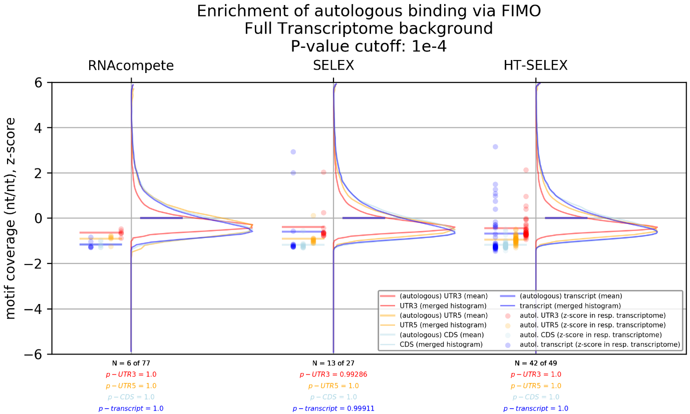

# References

|  |  |
| --- | --- |
| [1] | F. Crick, "Central Dogma of Molecular Biology," *Nature,* vol. 227, pp. 561-563, 1970. |
| [2] | M. Müller-McNicoll, O. Rossbach, J. Hui and J. Medenbach, "Auto-regulatory feedback by RNA-binding proteins," *Journal of Molecular Cell Biology,* vol. 11, no. 10, p. 930–939, 2019. |
| [3] | M. Corley, M. C. Burns and G. W. Yeo, "How RNA-Binding Proteins Interact with RNA: Molecules and Mechanisms," *Molecular Cell,* vol. 78, no. 1, pp. 9-29, 2020. |
| [4] | R. E. Halbeisen, A. Galgano, T. Scherrer and A. P. Gerber, "Post-transcriptional gene regulation: From genome-wide studies to principles," *Cellular and Molecular Life Sciences,* vol. 65, no. 5, pp. 798-813, 2008. |
| [5] | G. T, B. JL, Y. J and D. G, "RNA-binding proteins and post-transcriptional gene regulation," *Journal of the Federation of European Biochemical Societies,* vol. 582, no. 14, pp. 1977-1986, 2008. |
| [6] | A. A. Polyansky and B. Zagrovic, "Evidence of direct complementary interactions between messenger RNAs and their cognate proteins," *Nucleic acids research,* vol. 41, pp. 8434-8443, 2013. |
| [7] | C. KB, H. TR and M. QD, "High-throughput characterization of protein-RNA interactions," *Brief Funct Genomics,* vol. 14, no. 1, pp. 74-89, 2015. |
| [8] | R. D, H. KCH, N. K, Z. H, H. TR and M. QD., "RNAcompete methodology and application to determine sequence preferences of unconventional RNA-binding proteins," *Methods,* pp. 118-119, 2017. |
| [9] | F. Yasmeen, H. Seo, N. Javaid, M. S. Kim and S. Choi, "Therapeutic Interventions into Innate Immune Diseases by Means of Aptamers," *Pharmaceutics,* vol. 12, no. 10, p. 955, 2020. |
| [10] | C. E. Grant, T. L. Bailey and W. S. Noble, "FIMO: scanning for occurrences of a given motif," *Bioinformatics,* vol. 27, no. 7, pp. 1017-1018, 2011. |
| [11] | G. G, S.-C. F, T. C and L.-P. E, "ATtRACT-a database of RNA-binding proteins and associated motifs," *Database (Oxford),* 2016. |
| [12] | P. Flicek, M. Amode, D. Barrell, K. Beal, K. Billis, S. Brent, D. Carvalho-Silva, P. Clapham, G. Coates, S. Fitzgerald, L. Gil, C. Girón, L. Gordon, T. Hourlier, S. Hunt, N. Johnson, T. Juettemann, A. Kähäri, S. Keenan, E. Kulesha, F. Martin, T. Maurel, W. McLaren, D. Murphy, R. Nag, B. Overduin, M. Pignatelli, B. Pritchard, E. Pritchard, H. Riat, M. Ruffier, D. Sheppard, K. Taylor, A. Thormann, S. Trevanion, A. Vullo, S. Wilder, M. Wilson, A. Zadissa, B. Aken, E. Birney, F. Cunningham, J. Harrow, J. Herrero, T. Hubbard, R. Kinsella, M. Muffato, A. Parker, G. Spudich, A. Yates, D. Zerbino and S. Searle, "Ensembl 2014," *Nucleic Acids Research,* no. 42, pp. 749-755, 2014. |
| [13] | K. JB, F. JD, B. KA, J.-Z. C, P. VG, L. J, K. K, Z. AM and V. PD, "Xenbase, the Xenopus model organism database; new virtualized system, data types and genomes," *Nucleic Acids Research,* no. 43, pp. 756-763, 2015. |
| [14] | S. N, A. B, A. C, C.-T. A, C. I, G. R, G. N, T. H. P, K. S, L. R, L. W, L. X, L. R, P. N, P. S, P. S, R. R, R. M, S. A, S. D, T. AL, V. D, V. Zalunin and G. Cochrane, "Content discovery and retrieval services at the European Nucleotide Archive," *Nucleic Acids Research,* no. 43, pp. 23-29, 2015. |
| [15] | U. Consortium, "UniProt: a hub for protein information," *Nucleic Acids Research,* no. 43, pp. 204-212, 2015. |
| [16] | A. Jolma, J. Zhang, E. Mondragón, E. Morgunova, T. Kivioja, K. U. Laverty, Y. Yin, F. Zhu, G. Bourenkov, Q. Morris, T. R. Hughes, L. J. 3. Maher and J. Taipale, "Binding specificities of human RNA-binding proteins toward structures and linear RNA sequences," *Genome Research,* vol. 30, no. 7, pp. 962-973, 2020. |
| [17] | Y. Pan and S. Phan, "Guide to Threshold Selection for Motif Prediction Using Positional Weight Matrix," *Proceedings of the International MultiConference of Engineers and Computer Scientists,* vol. 1, pp. 19-21, 2008. |
| [18] | T. L. Bailey, J. Johnson, C. E. Grant and W. S. Noble, "The MEME Suite," *Nucleic Acids Research,* vol. 43, no. 1, pp. 39-49, 2015. |
| [19] | A. A. Polyansky, M. Hlevnjak and B. Zagrovic, "Proteome-wide analysis reveals clues of complementary interactions between mRNAs and their cognate proteins as the physicochemical foundation of the genetic code," *RNA biology,* vol. 10, pp. 1248-1254, 2013. |
| [20] | A. Theuer, "Analysis of autologous binding preferences of RNA-binding proteins," *Bachelor Thesis,* 2022. |
| [21] | B. Zagrovic, L. Bartonek and A. A. Polyansky, "RNA-protein interactions in an unstructured context," *FEBS letters,* vol. 592, pp. 2901-2916, 2018. |
| [22] | M. Hlevnjak, A. A. Polyansky and B. Zagrovic, "Sequence signatures of direct complementarity between mRNAs and cognate proteins on multiple levels," *Nucleic acids research,* vol. 40, pp. 8874-8882, 2012. |
| [23] | D. D, F. P, A. MS, S. A, H. M, P. T, B. C, L. NJ, V. N. EL, P. GA, Y. GW, G. BR and B. CB, "Sequence, Structure, and Context Preferences of Human RNA Binding Proteins," *Mol Cell,* vol. 70, no. 5, pp. 854-867, 2018. |
| [24] | J. Zhang, B. Jiang, M. Li, J. Tromp, X. Zhang and M. Q. Zhang, "Computing exact P-values for DNA motifs," *Bioinformatics,* vol. 23, no. 5, p. 531–537, 2007. |
| [25] | A. C. Allain and F. H.-T., "From Structure to Function of RNA Binding Domains," in *Madame Curie Bioscience Database [Internet]*, Austin (TX), Landes Bioscience, 2000-2013. |
| [26] | P. A. Chong, R. M. Vernon and J. D. Forman-Kay, "RGG/RG Motif Regions in RNA Binding and Phase Separation," *Journal of Molecular Biology,* vol. 430, no. 23, pp. 4650-5685, 2018. |

# Acknowledgements

Many thanks to Prof. Dr. Bojan Žagrović for the amazing opportunity of joining the Žagrović research group for the short duration of this project and for lending invaluable support whenever necessary while also giving me the space to explore this engaging research topic on my own. Being welcomed into the research group enabled me to work in a stimulating environment full of challenges to overcome and insights to gain.

I want to thank my direct supervisor, Thomas Kapral’s, who’s help was essential during the time I spent on this project. Not only did he lay the groundwork for this project, his technical know-how and scientific rigor played a vital role in progressing my work at a constant rate, and his openness for questions and willingness to help gave me the support needed to solve even the most difficult problems.

A big thank you also to Arthur Theuer for laying a solid foundation that I could build upon and for providing me with the code I could use to reproduce my result using the exact-matching procedure.

# Appendix

**Setting path for FIMO executable in command line**

export PATH=$HOME/meme/bin:$HOME/meme/libexec/meme-5.4.1:$PATH

To save space, the “—text” option in the FIMO command enables us to write the tab-separated data directly to the appropriate file.

First, make sure to create a .tsv file for each FIMO command you will run, e. g. for each output file you expect to have. In my case, this would be 12 files, each called “experiment_subsequence.tsv”. The commands to create these files are best executed from the “DATA” folder in my hierarchy, which is the main branching point for all the data FIMO needs. You can use the following commands to create the files:

cd DATA/FIMO_OUT

mkdir pval5e-2

touch pval5e-2/rnacompete_UTR3.tsv

Once the directories and files are in place, the FIMO commands are used as such:

fimo

--text

--max-stored-scores 2,147,483,646

--thresh 5e-2

--bfile FIMO_input/background_file.txt

FIMO_input/motifs/motif_file.txt

FIMO_input/sequences/transcript_file.txt

> FIMO_OUT/ target_file.tsv

Let’s break down each part of this command:

--text: reduces the output to “tsv” output sent to the standard-output, i. e. to the command line itself. This argument allows us to redirect the outputs to the appropriate file using the “>” operator.

--max-stored-scores: for score significance to be calculated, a certain number of matches will have to be held in memory. This argument is especially important when working with Q-values instead of P-values. The large number after the command is the maximum number of stored scores FIMO allows for.

--thresh: sets the custom P-value cutoff. The default cutoff lies at 1e-4.

--bfile: after this argument, a file containing the nucleotide frequency distribution of the background is added – in my example called “background_file.txt”. This file can be created using the “fasta-get-markov” command, which is distributed together with MEME Suite. More on this command below. The background file contains a zero-order Markov model of the background distribution. No higher order models are allowed as input to FIMO. If a higher order model is entered, FIMO will only consider the zero-order part.

The penultimate argument hands the input motif file to FIMO, while the last one enters the sequence file.

The “>”-operator: In Linux, this operator is often used to write the output of a command to a file. Additionally, this operator overwrites the contents of the file, if they exist.

For each experiment-subsequence combination (e. g. RNAcompete+CDS, SELEX+UTR3 etc.) such a command must be constructed. The choice of background file and P-value threshold is left up to the user. To chain up multiple of these commands, one can place a semicolon “;” or an “and”-operator “&&” in between. While for the “and”-operator, the preceding command must have been completed successfully, the semicolon chains up commands without requiring successful completion.

Here are all FIMO commands I used, chained up by semicolons:

cd ~; cd Moritz_BSc/BSc_enriched_autologous_RBP/DATA/

Creation of file containing background nucleotide frequencies:

fasta-get-markov sequences/fimo_transcriptome_full.txt

folder system by cutoff:

pval5e-2

pval1e-2

pval1e-3

pval1e-4

cd FIMO_OUT

mkdir pval5e-2

touch pval5e-2/rnacompete_UTR3.tsv

touch pval5e-2/rnacompete_CDS.tsv

touch pval5e-2/rnacompete_UTR5.tsv

touch pval5e-2/rnacompete_full.tsv

touch pval5e-2/selex_UTR3.tsv

touch pval5e-2/selex_CDS.tsv

touch pval5e-2/selex_UTR5.tsv

touch pval5e-2/selex_full.tsv

touch pval5e-2/htselex_UTR3.tsv

touch pval5e-2/htselex_CDS.tsv

touch pval5e-2/htselex_UTR5.tsv

touch pval5e-2/htselex_full.tsv

mkdir pval1e-2

touch pval1e-2/rnacompete_UTR3.tsv

touch pval1e-2/rnacompete_CDS.tsv

touch pval1e-2/rnacompete_UTR5.tsv

touch pval1e-2/rnacompete_full.tsv

touch pval1e-2/selex_UTR3.tsv

touch pval1e-2/selex_CDS.tsv

touch pval1e-2/selex_UTR5.tsv

touch pval1e-2/selex_full.tsv

touch pval1e-2/htselex_UTR3.tsv

touch pval1e-2/htselex_CDS.tsv

touch pval1e-2/htselex_UTR5.tsv

touch pval1e-2/htselex_full.tsv

mkdir pval1e-3

touch pval1e-3/rnacompete_UTR3.tsv

touch pval1e-3/rnacompete_CDS.tsv

touch pval1e-3/rnacompete_UTR5.tsv

touch pval1e-3/rnacompete_full.tsv

touch pval1e-3/selex_UTR3.tsv

touch pval1e-3/selex_CDS.tsv

touch pval1e-3/selex_UTR5.tsv

touch pval1e-3/selex_full.tsv

touch pval1e-3/htselex_UTR3.tsv

touch pval1e-3/htselex_CDS.tsv

touch pval1e-3/htselex_UTR5.tsv

touch pval1e-3/htselex_full.tsv

mkdir pval1e-4

touch pval1e-4/rnacompete_UTR3.tsv

touch pval1e-4/rnacompete_CDS.tsv

touch pval1e-4/rnacompete_UTR5.tsv

touch pval1e-4/rnacompete_full.tsv

touch pval1e-4/selex_UTR3.tsv

touch pval1e-4/selex_CDS.tsv

touch pval1e-4/selex_UTR5.tsv

touch pval1e-4/selex_full.tsv

touch pval1e-4/htselex_UTR3.tsv

touch pval1e-4/htselex_CDS.tsv

touch pval1e-4/htselex_UTR5.tsv

touch pval1e-4/htselex_full.tsv

**Pvalue: 1e-4**

**ATtRACT - SELEX**

fimo --text --max-stored-scores 21474836466 --thresh 1e-4 --bfile FIMO_input/markov_full.txt FIMO_input/motifs/fimo_attract_selex.txt FIMO_input/sequences/fimo_transcriptome_5utr.txt > FIMO_OUT/pval1e-4/selex_UTR5.tsv;

fimo --text --max-stored-scores 21474836466 --thresh 1e-4 --bfile FIMO_input/markov_full.txt FIMO_input/motifs/fimo_attract_selex.txt FIMO_input/sequences/fimo_transcriptome_cds.txt > FIMO_OUT/pval1e-4/selex_CDS.tsv;

fimo --text --max-stored-scores 21474836466 --thresh 1e-4 --bfile FIMO_input/markov_full.txt FIMO_input/motifs/fimo_attract_selex.txt FIMO_input/sequences/fimo_transcriptome_3utr.txt > FIMO_OUT/pval1e-4/selex_UTR3.tsv;

fimo --text --max-stored-scores 21474836466 --thresh 1e-4 --bfile FIMO_input/markov_full.txt FIMO_input/motifs/fimo_attract_selex.txt FIMO_input/sequences/fimo_transcriptome_full.txt > FIMO_OUT/pval1e-4/selex_full.tsv

**ATtRACT - RNAcompete**

fimo --text --max-stored-scores 21474836466 --thresh 1e-4 --bfile FIMO_input/markov_full.txt FIMO_input/motifs/fimo_attract_rnacomp.txt FIMO_input/sequences/fimo_transcriptome_5utr.txt > FIMO_OUT/pval1e-4/rnacompete_UTR5.tsv;

fimo --text --max-stored-scores 21474836466 --thresh 1e-4 --bfile FIMO_input/markov_full.txt FIMO_input/motifs/fimo_attract_rnacomp.txt FIMO_input/sequences/fimo_transcriptome_cds.txt > FIMO_OUT/pval1e-4/rnacompete_CDS.tsv;

fimo --text --max-stored-scores 21474836466 --thresh 1e-4 --bfile FIMO_input/markov_full.txt FIMO_input/motifs/fimo_attract_rnacomp.txt FIMO_input/sequences/fimo_transcriptome_3utr.txt > FIMO_OUT/pval1e-4/rnacompete_UTR3.tsv;

fimo --text --max-stored-scores 21474836466 --thresh 1e-4 --bfile FIMO_input/markov_full.txt FIMO_input/motifs/fimo_attract_rnacomp.txt FIMO_input/sequences/fimo_transcriptome_full.txt > FIMO_OUT/pval1e-4/rnacompete_full.tsv

**HT-SELEX**

fimo --text --max-stored-scores 21474836466 --thresh 1e-4 --bfile FIMO_input/markov_full.txt FIMO_input/motifs/fimo_htselex.txt FIMO_input/sequences/fimo_transcriptome_5utr.txt > FIMO_OUT/pval1e-4/htselex_UTR5.tsv;

fimo --text --max-stored-scores 21474836466 --thresh 1e-4 --bfile FIMO_input/markov_full.txt FIMO_input/motifs/fimo_htselex.txt FIMO_input/sequences/fimo_transcriptome_cds.txt > FIMO_OUT/pval1e-4/htselex_CDS.tsv;

fimo --text --max-stored-scores 21474836466 --thresh 1e-4 --bfile FIMO_input/markov_full.txt FIMO_input/motifs/fimo_htselex.txt FIMO_input/sequences/fimo_transcriptome_3utr.txt > FIMO_OUT/pval1e-4/htselex_UTR3.tsv;

fimo --text --max-stored-scores 21474836466 --thresh 1e-4 --bfile FIMO_input/markov_full.txt FIMO_input/motifs/fimo_htselex.txt FIMO_input/sequences/fimo_transcriptome_full.txt > FIMO_OUT/pval1e-4/htselex_full.tsv

**Pvalue: 1e-3**

**ATtRACT - SELEX**

fimo --text --max-stored-scores 2147483646 --thresh 1e-3 --bfile FIMO_input/markov_full.txt FIMO_input/motifs/fimo_attract_selex.txt FIMO_input/sequences/fimo_transcriptome_5utr.txt > FIMO_OUT/pval1e-3/selex_UTR5.tsv;

fimo --text --max-stored-scores 2147483646 --thresh 1e-3 --bfile FIMO_input/markov_full.txt FIMO_input/motifs/fimo_attract_selex.txt FIMO_input/sequences/fimo_transcriptome_cds.txt > FIMO_OUT/pval1e-3/selex_CDS.tsv;

fimo --text --max-stored-scores 2147483646 --thresh 1e-3 --bfile FIMO_input/markov_full.txt FIMO_input/motifs/fimo_attract_selex.txt FIMO_input/sequences/fimo_transcriptome_3utr.txt > FIMO_OUT/pval1e-3/selex_UTR3.tsv;

fimo --text --max-stored-scores 2147483646 --thresh 1e-3 --bfile FIMO_input/markov_full.txt FIMO_input/motifs/fimo_attract_selex.txt FIMO_input/sequences/fimo_transcriptome_full.txt > FIMO_OUT/pval1e-3/selex_full.tsv

**ATtRACT - RNAcompete**

fimo --text --max-stored-scores 2147483646 --thresh 1e-3 --bfile FIMO_input/markov_full.txt FIMO_input/motifs/fimo_attract_rnacomp.txt FIMO_input/sequences/fimo_transcriptome_5utr.txt > FIMO_OUT/pval1e-3/rnacompete_UTR5.tsv;

fimo --text --max-stored-scores 2147483646 --thresh 1e-3 --bfile FIMO_input/markov_full.txt FIMO_input/motifs/fimo_attract_rnacomp.txt FIMO_input/sequences/fimo_transcriptome_cds.txt > FIMO_OUT/pval1e-3/rnacompete_CDS.tsv;

fimo --text --max-stored-scores 2147483646 --thresh 1e-3 --bfile FIMO_input/markov_full.txt FIMO_input/motifs/fimo_attract_rnacomp.txt FIMO_input/sequences/fimo_transcriptome_3utr.txt > FIMO_OUT/pval1e-3/rnacompete_UTR3.tsv;

fimo --text --max-stored-scores 2147483646 --thresh 1e-3 --bfile FIMO_input/markov_full.txt FIMO_input/motifs/fimo_attract_rnacomp.txt FIMO_input/sequences/fimo_transcriptome_full.txt > FIMO_OUT/pval1e-3/rnacompete_full.tsv

**HT-SELEX**

fimo --text --max-stored-scores 2147483646 --thresh 1e-3 --bfile FIMO_input/markov_full.txt FIMO_input/motifs/fimo_htselex.txt FIMO_input/sequences/fimo_transcriptome_5utr.txt > FIMO_OUT/pval1e-3/htselex_UTR5.tsv;

fimo --text --max-stored-scores 2147483646 --thresh 1e-3 --bfile FIMO_input/markov_full.txt FIMO_input/motifs/fimo_htselex.txt FIMO_input/sequences/fimo_transcriptome_cds.txt > FIMO_OUT/pval1e-3/htselex_CDS.tsv;

fimo --text --max-stored-scores 2147483646 --thresh 1e-3 --bfile FIMO_input/markov_full.txt FIMO_input/motifs/fimo_htselex.txt FIMO_input/sequences/fimo_transcriptome_3utr.txt > FIMO_OUT/pval1e-3/htselex_UTR3.tsv;

fimo --text --max-stored-scores 2147483646 --thresh 1e-3 --bfile FIMO_input/markov_full.txt FIMO_input/motifs/fimo_htselex.txt FIMO_input/sequences/fimo_transcriptome_full.txt > FIMO_OUT/pval1e-3/htselex_full.tsv

**Pvalue: 1e-2**

**ATtRACT - SELEX**

fimo --text --max-stored-scores 2147483646 --thresh 1e-2 --bfile FIMO_input/markov_full.txt FIMO_input/motifs/fimo_attract_selex.txt FIMO_input/sequences/fimo_transcriptome_5utr.txt > FIMO_OUT/pval1e-2/selex_UTR5.tsv;

fimo --text --max-stored-scores 2147483646 --thresh 1e-2 --bfile FIMO_input/markov_full.txt FIMO_input/motifs/fimo_attract_selex.txt FIMO_input/sequences/fimo_transcriptome_cds.txt > FIMO_OUT/pval1e-2/selex_CDS.tsv;

fimo --text --max-stored-scores 2147483646 --thresh 1e-2 --bfile FIMO_input/markov_full.txt FIMO_input/motifs/fimo_attract_selex.txt FIMO_input/sequences/fimo_transcriptome_3utr.txt > FIMO_OUT/pval1e-2/selex_UTR3.tsv;

fimo --text --max-stored-scores 2147483646 --thresh 1e-2 --bfile FIMO_input/markov_full.txt FIMO_input/motifs/fimo_attract_selex.txt FIMO_input/sequences/fimo_transcriptome_full.txt > FIMO_OUT/pval1e-2/selex_full.tsv

**ATtRACT - RNAcompete**

fimo --text --max-stored-scores 2147483646 --thresh 1e-2 --bfile FIMO_input/markov_full.txt FIMO_input/motifs/fimo_attract_rnacomp.txt FIMO_input/sequences/fimo_transcriptome_5utr.txt > FIMO_OUT/pval1e-2/rnacompete_UTR5.tsv;

fimo --text --max-stored-scores 2147483646 --thresh 1e-2 --bfile FIMO_input/markov_full.txt FIMO_input/motifs/fimo_attract_rnacomp.txt FIMO_input/sequences/fimo_transcriptome_cds.txt > FIMO_OUT/pval1e-2/rnacompete_CDS.tsv;

fimo --text --max-stored-scores 2147483646 --thresh 1e-2 --bfile FIMO_input/markov_full.txt FIMO_input/motifs/fimo_attract_rnacomp.txt FIMO_input/sequences/fimo_transcriptome_3utr.txt > FIMO_OUT/pval1e-2/rnacompete_UTR3.tsv;

fimo --text --max-stored-scores 2147483646 --thresh 1e-2 --bfile FIMO_input/markov_full.txt FIMO_input/motifs/fimo_attract_rnacomp.txt FIMO_input/sequences/fimo_transcriptome_full.txt > FIMO_OUT/pval1e-2/rnacompete_full.tsv;

**HT-SELEX**

fimo --text --max-stored-scores 2147483646 --thresh 1e-2 --bfile FIMO_input/markov_full.txt FIMO_input/motifs/fimo_htselex.txt FIMO_input/sequences/fimo_transcriptome_5utr.txt > FIMO_OUT/pval1e-2/htselex_UTR5.tsv;

fimo --text --max-stored-scores 2147483646 --thresh 1e-2 --bfile FIMO_input/markov_full.txt FIMO_input/motifs/fimo_htselex.txt FIMO_input/sequences/fimo_transcriptome_cds.txt > FIMO_OUT/pval1e-2/htselex_CDS.tsv;

fimo --text --max-stored-scores 2147483646 --thresh 1e-2 --bfile FIMO_input/markov_full.txt FIMO_input/motifs/fimo_htselex.txt FIMO_input/sequences/fimo_transcriptome_3utr.txt > FIMO_OUT/pval1e-2/htselex_UTR3.tsv;

fimo --text --max-stored-scores 2147483646 --thresh 1e-2 --bfile FIMO_input/markov_full.txt FIMO_input/motifs/fimo_htselex.txt FIMO_input/sequences/fimo_transcriptome_full.txt > FIMO_OUT/pval1e-2/htselex_full.tsv

**Pvalue 5e-2**

**ATtRACT - SELEX**

fimo --text --max-stored-scores 2147483646 --thresh 5e-2 --bfile FIMO_input/markov_full.txt FIMO_input/motifs/fimo_attract_selex.txt FIMO_input/sequences/fimo_transcriptome_5utr.txt > FIMO_OUT/pval5e-2/selex_UTR5.tsv;

fimo --text --max-stored-scores 2147483646 --thresh 5e-2 --bfile FIMO_input/markov_full.txt FIMO_input/motifs/fimo_attract_selex.txt FIMO_input/sequences/fimo_transcriptome_cds.txt > FIMO_OUT/pval5e-2/selex_CDS.tsv;

fimo --text --max-stored-scores 2147483646 --thresh 5e-2 --bfile FIMO_input/markov_full.txt FIMO_input/motifs/fimo_attract_selex.txt FIMO_input/sequences/fimo_transcriptome_3utr.txt > FIMO_OUT/pval5e-2/selex_UTR3.tsv;

fimo --text --max-stored-scores 2147483646 --thresh 5e-2 --bfile FIMO_input/markov_full.txt FIMO_input/motifs/fimo_attract_selex.txt FIMO_input/sequences/fimo_transcriptome_full.txt > FIMO_OUT/pval5e-2/selex_full.tsv

**ATtRACT - RNAcompete**

fimo --text --max-stored-scores 2147483646 --thresh 5e-2 --bfile FIMO_input/markov_full.txt FIMO_input/motifs/fimo_attract_rnacomp.txt FIMO_input/sequences/fimo_transcriptome_5utr.txt > FIMO_OUT/pval5e-2/rnacompete_UTR5.tsv;

fimo --text --max-stored-scores 2147483646 --thresh 5e-2 --bfile FIMO_input/markov_full.txt FIMO_input/motifs/fimo_attract_rnacomp.txt FIMO_input/sequences/fimo_transcriptome_cds.txt > FIMO_OUT/pval5e-2/rnacompete_CDS.tsv;

fimo --text --max-stored-scores 2147483646 --thresh 5e-2 --bfile FIMO_input/markov_full.txt FIMO_input/motifs/fimo_attract_rnacomp.txt FIMO_input/sequences/fimo_transcriptome_3utr.txt > FIMO_OUT/pval5e-2/rnacompete_UTR3.tsv;

fimo --text --max-stored-scores 2147483646 --thresh 5e-2 --bfile FIMO_input/markov_full.txt FIMO_input/motifs/fimo_attract_rnacomp.txt FIMO_input/sequences/fimo_transcriptome_full.txt > FIMO_OUT/pval5e-2/rnacompete_full.tsv

**HT-SELEX**

fimo --text --max-stored-scores 2147483646 --thresh 5e-2 --bfile FIMO_input/markov_full.txt FIMO_input/motifs/fimo_htselex.txt FIMO_input/sequences/fimo_transcriptome_5utr.txt > FIMO_OUT/pval5e-2/htselex_UTR5.tsv;

fimo --text --max-stored-scores 2147483646 --thresh 5e-2 --bfile FIMO_input/markov_full.txt FIMO_input/motifs/fimo_htselex.txt FIMO_input/sequences/fimo_transcriptome_cds.txt > FIMO_OUT/pval5e-2/htselex_CDS.tsv;

fimo --text --max-stored-scores 2147483646 --thresh 5e-2 --bfile FIMO_input/markov_full.txt FIMO_input/motifs/fimo_htselex.txt FIMO_input/sequences/fimo_transcriptome_3utr.txt > FIMO_OUT/pval5e-2/htselex_UTR3.tsv;

fimo --text --max-stored-scores 2147483646 --thresh 5e-2 --bfile FIMO_input/markov_full.txt FIMO_input/motifs/fimo_htselex.txt FIMO_input/sequences/fimo_transcriptome_full.txt > FIMO_OUT/pval5e-2/htselex_full.tsv